Sample Backgrounds without any text, with FOSSASIA logo (non-editable text), with FOSSASIA logo and editable text (lime ‘BUSINESS PASS, VIP etc).

**1). Sample background.svg** :

Find 'layer 1', then replace the value of the 'fill' attribute with required color code in your text editor.

**example:** 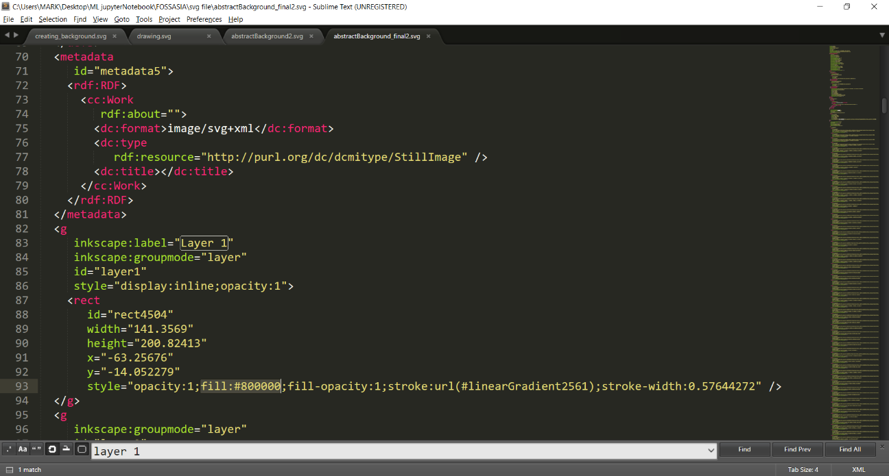

**o/p**:

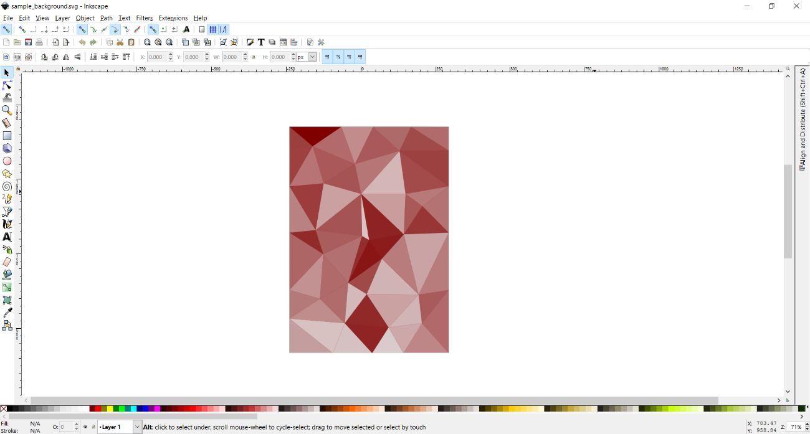

**If fill' value is changed to say to 37C871:  
o/p:**

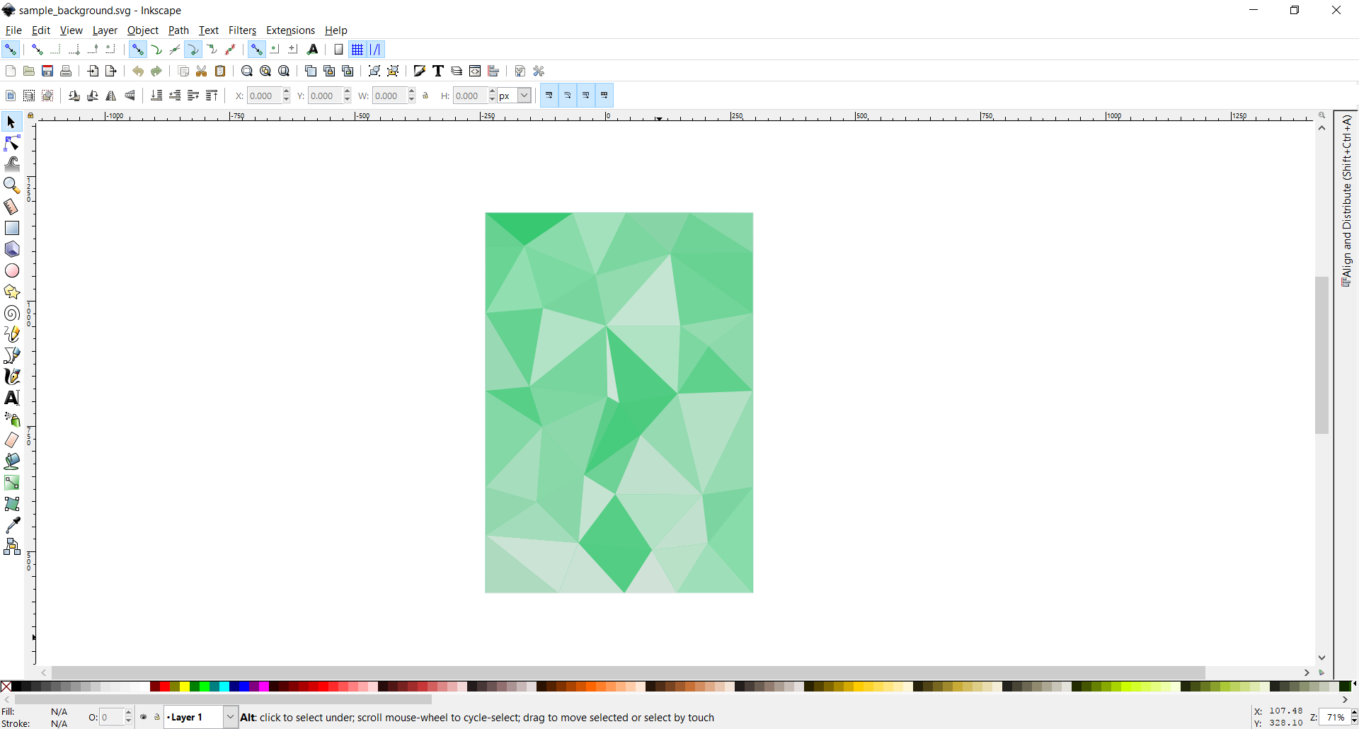

PS: you can edit the 'opacity' too to get different results :).

**2). Sample background FOSSASIA.svg**

In this FOSSASIA logo is attatched to the top of the background, giving the look of a badge. Note this is not a text! This is logo image, so its non editable by text editor. Couldn’t find the logo font of FOSSASIA.

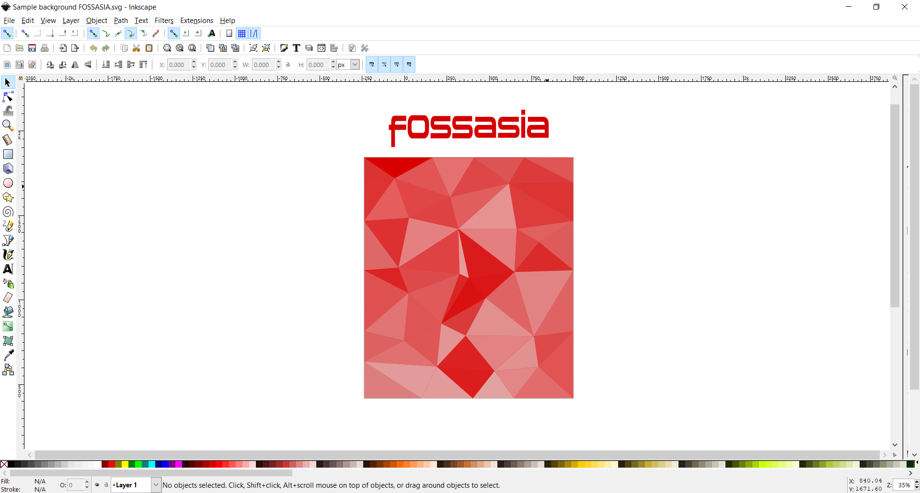

**3). Sample background FOSSASIA_text.svg**

This is for following badge creation:

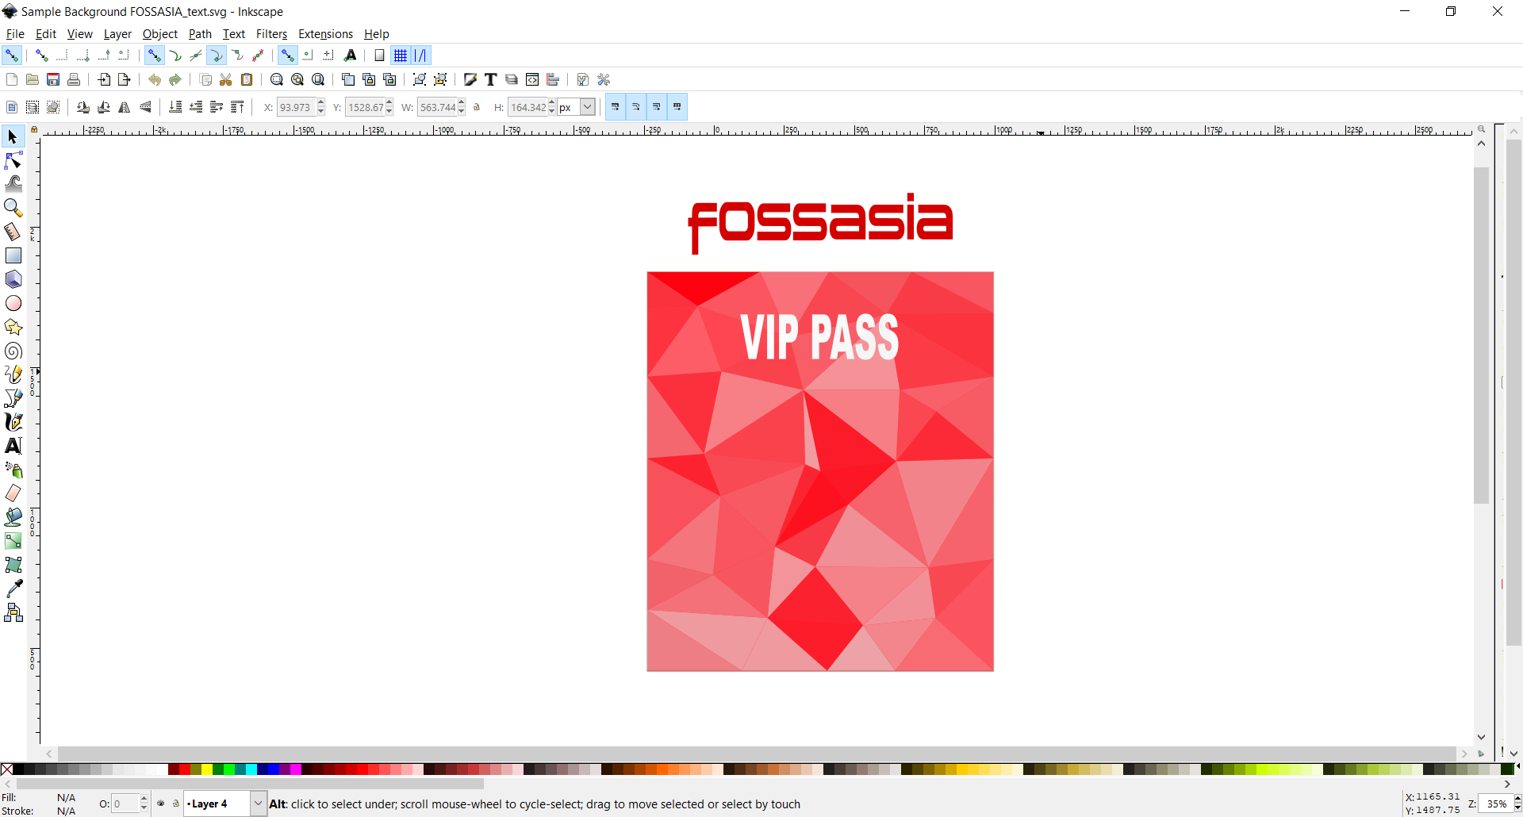

Now the text ‘VIP PASS’ is editable i.e. FIND the text (here VIP PASS) in your text editor, replace it with required text, say, ‘BUSINESS PASS’.

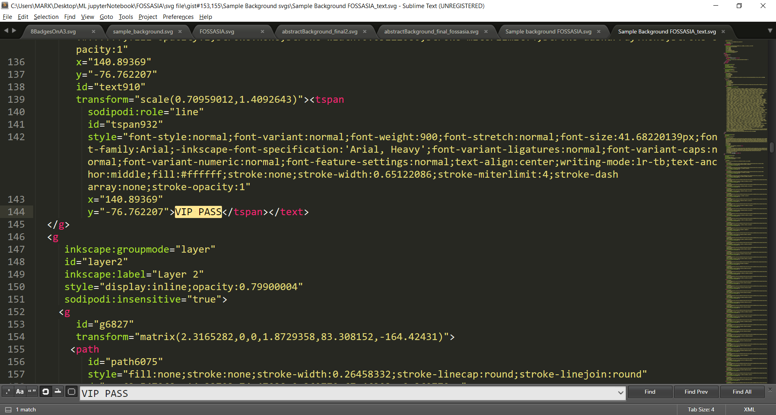

**O/P:**

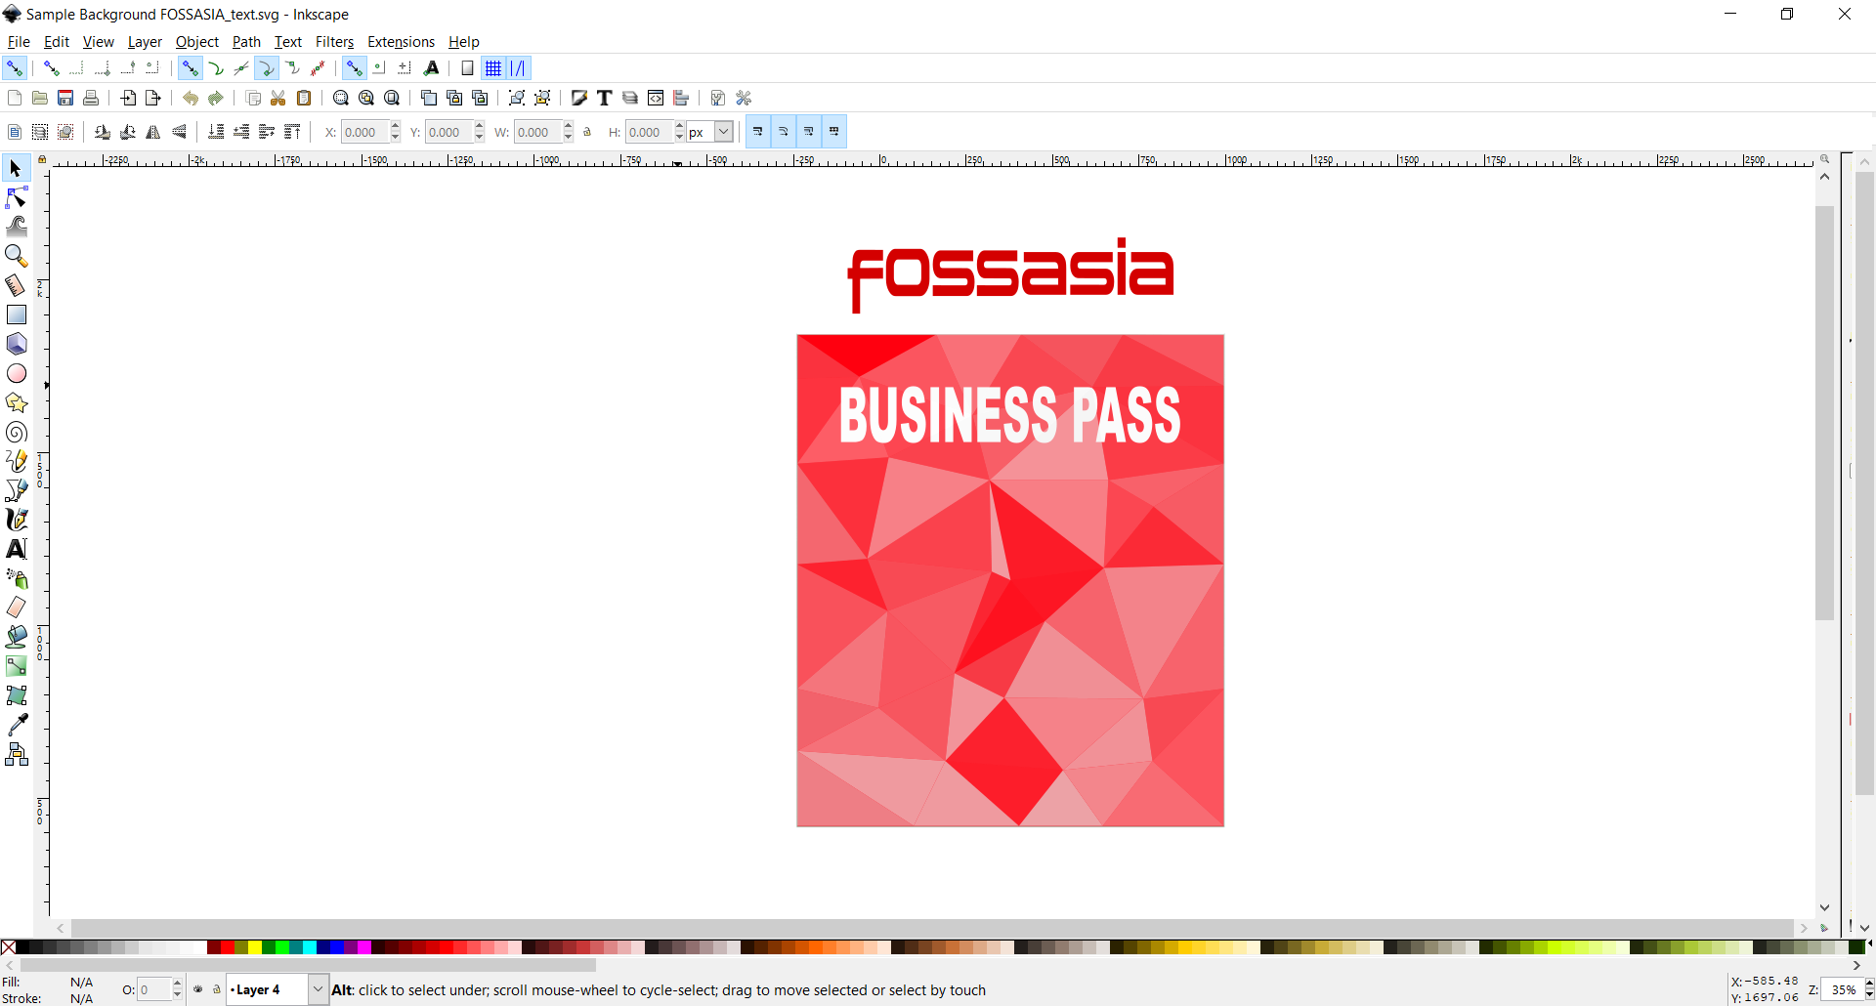

**Text is vertically centrally aligned. So will be for any text!**